Press release
2 December 2019

Euro area insurance corporation statistics: third quarter of 2019
  - Total assets of euro area insurance corporations amounted to €8,764 billion in third quarter of 2019, €291 billion higher than in second quarter of 2019
  - Total insurance technical reserves of euro area insurance corporations rose to €6,733 billion in third quarter, up €249 billion from second quarter
Total assets of euro area insurance corporations increased to €8,764 billion in the third quarter of 2019, from €8,473 billion in the second quarter. Debt securities accounted for 41.5% of the sector's total assets in the third quarter. The second largest category of holdings was investment fund shares (26.1%), followed by equity (10.3%) and loans (7.0%).
Holdings of debt securities increased to €3,640 billion at the end of the third quarter from €3,520 billion at the end of the previous quarter (see Chart 1). Net purchases of debt securities amounted to €28 billion in the third quarter; price and other changes amounted to €91 billion. The year-on-year growth rate of debt securities held was 3.0%.
Looking at holdings by issuing sector, the annual growth rate of debt securities issued by euro area general government was 1.9% in the third quarter of 2019, with net purchases in the quarter amounting to €8 billion. As regards debt securities issued by the private sector, the annual growth rate was 3.7%, and quarterly net purchases amounted to €13 billion. For debt securities issued by non-euro area residents, the annual growth rate was 4.7%, with quarterly net purchases of €7 billion.
Chart 1
Insurance corporations' holdings of debt securities by issuing sector
(quarterly transactions in EUR billions; not seasonally adjusted)
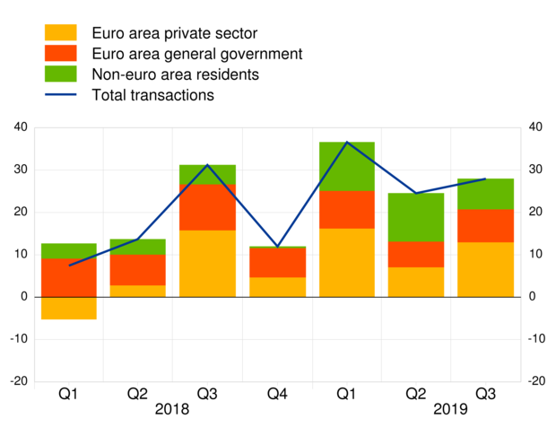
Data for insurance corporations' holdings of debt securities by issuing sector

Turning to insurance corporations' holdings of investment fund shares, these increased to €2,288 billion in the third quarter of 2019, from €2,205 billion in the previous quarter, with net purchases of €35 billion and price and other changes of €48 billion (see Chart 2). The year-on-year growth rate in the third quarter was 3.4%.
The annual growth rate of euro area money market fund shares held by insurance corporations was 15.0% in the third quarter of 2019, with net purchases in the quarter amounting to €2 billion. As regards holdings of euro area non-money market fund shares, the annual growth rate was 4.5%, with quarterly net purchases amounting to €33 billion. For investment fund shares issued by non-euro area residents, the annual growth rate was -16.9%, with quarterly net sales of €0 billion.
Chart 2
Insurance corporations' holdings of investment fund shares by issuing sector
(quarterly transactions in EUR billions; not seasonally adjusted)
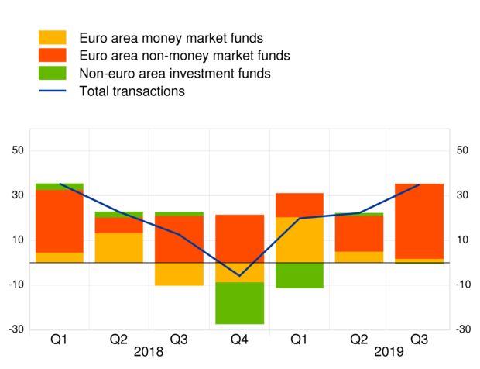
Data for insurance corporations' holdings of investment fund shares by issuing sector

In terms of main liabilities, total insurance technical reserves of insurance corporations amounted to €6,733 billion in the third quarter of 2019, up from €6,484 billion in the second quarter (see Annex). Life insurance technical reserves accounted for 91.0% of total insurance technical reserves in the third quarter. Unit-linked products amounted to €1,266 billion, accounting for 20.7% of total life insurance technical reserves.

Annex
Annex: Table on euro area insurance corporations
For media queries, please contact Stefan Ruhkamp, tel.: +49 69 1344 5057.
Notes:
- "Other assets" includes currency and deposits, insurance technical reserves and related claims, financial derivatives, non-financial assets and remaining assets.
- "Private sector" refers to euro area excluding general government.
- "Investment funds" includes money market funds and non-money market funds.
- Hyperlinks in the main body of the press release and in the annex table lead to data that may change with subsequent releases as a result of revisions. Figures shown in the annex table are a snapshot of the data as at the time of the current release.

